**Pharma Sales Dashboard**

**Sales details:-**

**Task 1:Sales By Customer.**

**Task 2:Sales By Location.**

**Task 3:Sales By Sales Representative.**

**Task 4: Received Inventory From Supplier**

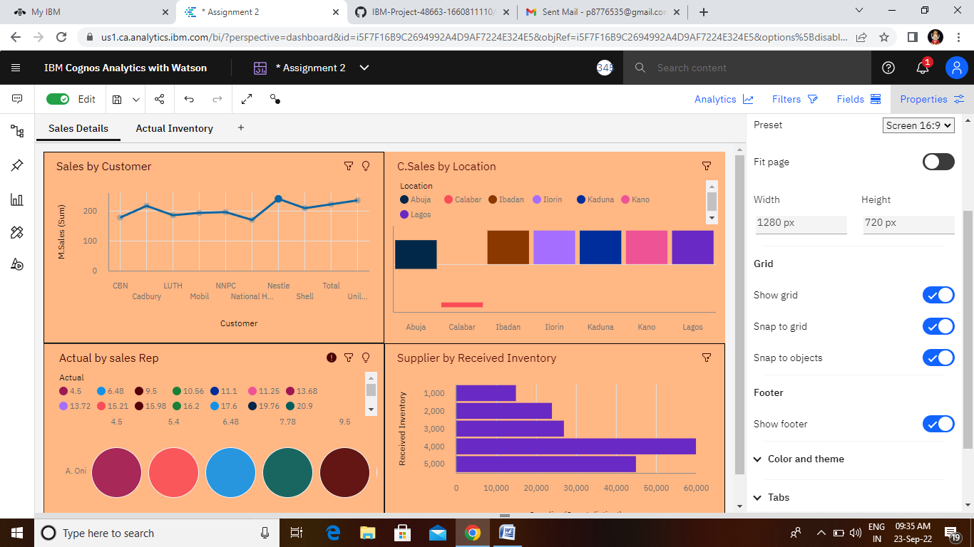

[**https://us1.ca.analytics.ibm.com/bi/?perspective=dashboard&pathRef=.my_folders%2FAssignment%2B2&action=view&mode=dashboard&subView=model0000018369b10746_00000000**](https://us1.ca.analytics.ibm.com/bi/?perspective=dashboard&pathRef=.my_folders%2FAssignment%2B2&action=view&mode=dashboard&subView=model0000018369b10746_00000000)

Actual Inventory:-

Task 5: Inventory Stock for Warehouse Locations

Task 6: Sales Trend

Task 7:Monthly Sales

Task 8: Actual and Received Inventory by Month

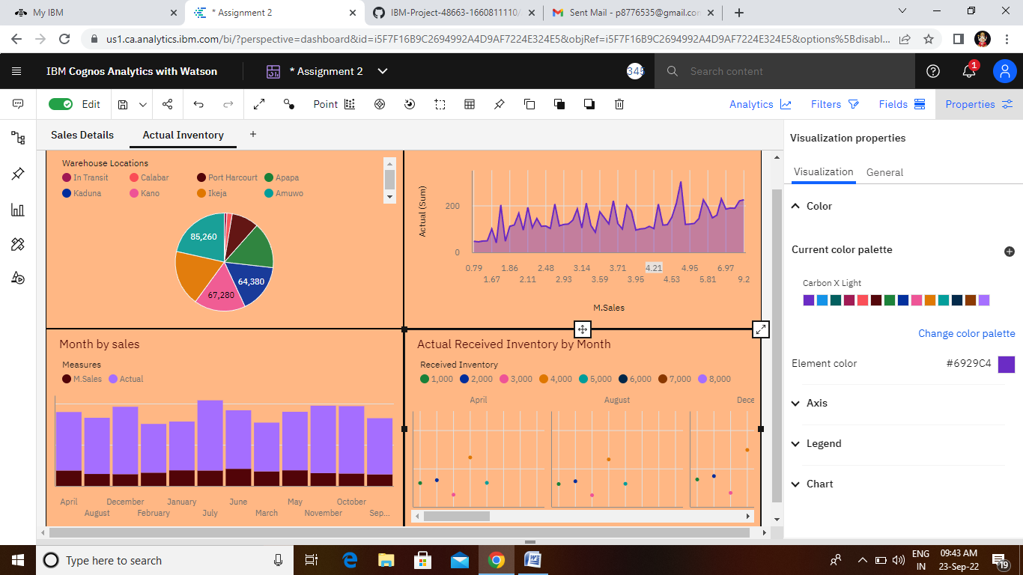

<https://us1.ca.analytics.ibm.com/bi/?perspective=dashboard&pathRef=.my_folders%2FAssignment%2B2&action=view&mode=dashboard&subView=model0000018369d2e91b_00000000>